


PQCT Preparation Guideline

Item No. 1: Purpose
Item No. 2: Applicable Scope
Item No. 3: Definition
Item No. 4: Preparation Stage
Item No. 5: Making Procedure
Item No. 5-1: Correspondence Plan
Item No. 6: Approval
Item No. 7: Retention
Item No. 8: Changes

Additional Rule-Revision decision

Formats :
Format-1 : PQCT-1
Format-1 : PQCT-2
Format-3 : PQCT release records

Item No. 1 : Purpose

This guideline is to clarify the creation and revision procedures of PQCT (which will be the base of Product Quality Assurance) & at the same time it is intended to ensure the control of the production process and product quality assurance by its compliance.

Item No. 2: Applicable Scope

It is applicable for all the mass production products and new development stage, which order has been received from customers.

Item No. 3: Definition

PQCT specifies the agreement on quality with the customer, and quality control of in-house production. Process quality control table, QC process table, and the quality control table specified by the customers, also have the same meanings as PQCT.

Item No. 4: Preparation Stage

PQCT will be created in the following stages -

- New development event – Prototype & prelaunch
- Mass production start
- Change point if any, after mass production

Item No. 5: Making Procedure

Quality assurance representative of APQP team will make the PQCT-I & II with ingredients from process sheets (made by PE & APQP-CFT members including manufacturing conditions and checking frequency) and inspection standard received from customer.
However, if there is any instruction (including format) available from customer side, related to PQCT Preparation, the same should need to be followed.

QA need to confirm that there should not be any mismatch or typing miss in items mentioned in Process sheet & PQCT/PQCS, QA shall carryout point by point cross check. (tick mark √ required for point by point cross check )

Following items will be included in PQCT.
- Complete sequence of process from receiving inspection of input material from supplier to customer dispatch (including PDI at Final Inspection).
- Process/equipment used as per process flow.
- Control items of each process for quality characteristics including Control items, Standard value, Checked by, Checking method, frequency, data type (recording method),data filing frequency & production condition control items etc.
- It should reflect, customer`s inspection standard, Quality agreement documents with supplier/customer & the internal inspection standard.
- The Items for which random inspection cannot be done in machining process on automatic line, for them inspection item should be assumed from the operation for which inspection can be done after considering the actual operation.

- Important Items (Special characteristics)
- All the important items, in case of customer instruction - mark as customer specified, in case of internally decided items - mark as internal, should be mentioned as per Important Characteristic List, Process FMEA prepared (PE with CFT) at the time of Process design. In addition, if there is any instruction from customer side for failure mode, the same need to be followed.
- Equipment parameter control, which is required to fulfill the important items of quality characteristics, should also be described as important items as defined in process sheet by PE.
- For Important items (special characteristics’), utilize X-R Chart etc. to keep the record as per process sheet.

- Statistical method used at each process (If required)

Item No. 5-1: Correspondence Plan

If the process is unstable or its statistically-capacities are lost, then production department should segregate the parts, and stabilize the process with the add from PE team, and prepare a correct plan with required capacities, which clearly specified the time limit and responsible person in charge, and implement the same.(Individual improvement execution plan etc.)

Item No. 6: Approval

QA department will do the final check, whether all the important characteristics as mentioned by customer and Process FMEA (by PE & CFT) are correctly reflecting in PQCT or not, after that the same need to be released to process.

QA Department will submit the PQCT (for which submission request has been received from Customer), and take approval from customer, and keep the original copy of PQCT. Approved PQCT to be released to PE and production and maintain the latest revision report.

Item No. 7: Retention

QA Department will keep the original copy & old edition of PQCT & PQCT Release・Revision Notification as per Quality records Retention procedure. If there is any requirement from customer, that need to be followed.
In case of keeping old version, keep them in such a way so it can be easily understandable (old version).

Item No. 8: Changes

If there is any changes in the process sheet, PFMEA, customer spec or internal process change etc in that case, PE, QA, Production In charge & Concern member of APQP team will change the PQCT and will submit revised PQCT to customer for approval. After approval from customer control copy of the PQCT to be released to production and PE.

Incase QA department is revising the PQCT, QA need to confirm that there should not be any mismatch or typing miss in revised items by comparing it with input information and carrying out point by point cross check. (tick mark √ required for point by point cross check )

Additional Clause

- Revision Decision
Revision of this guideline should be decided by QA HOD, after consulting all the
Concern departments.

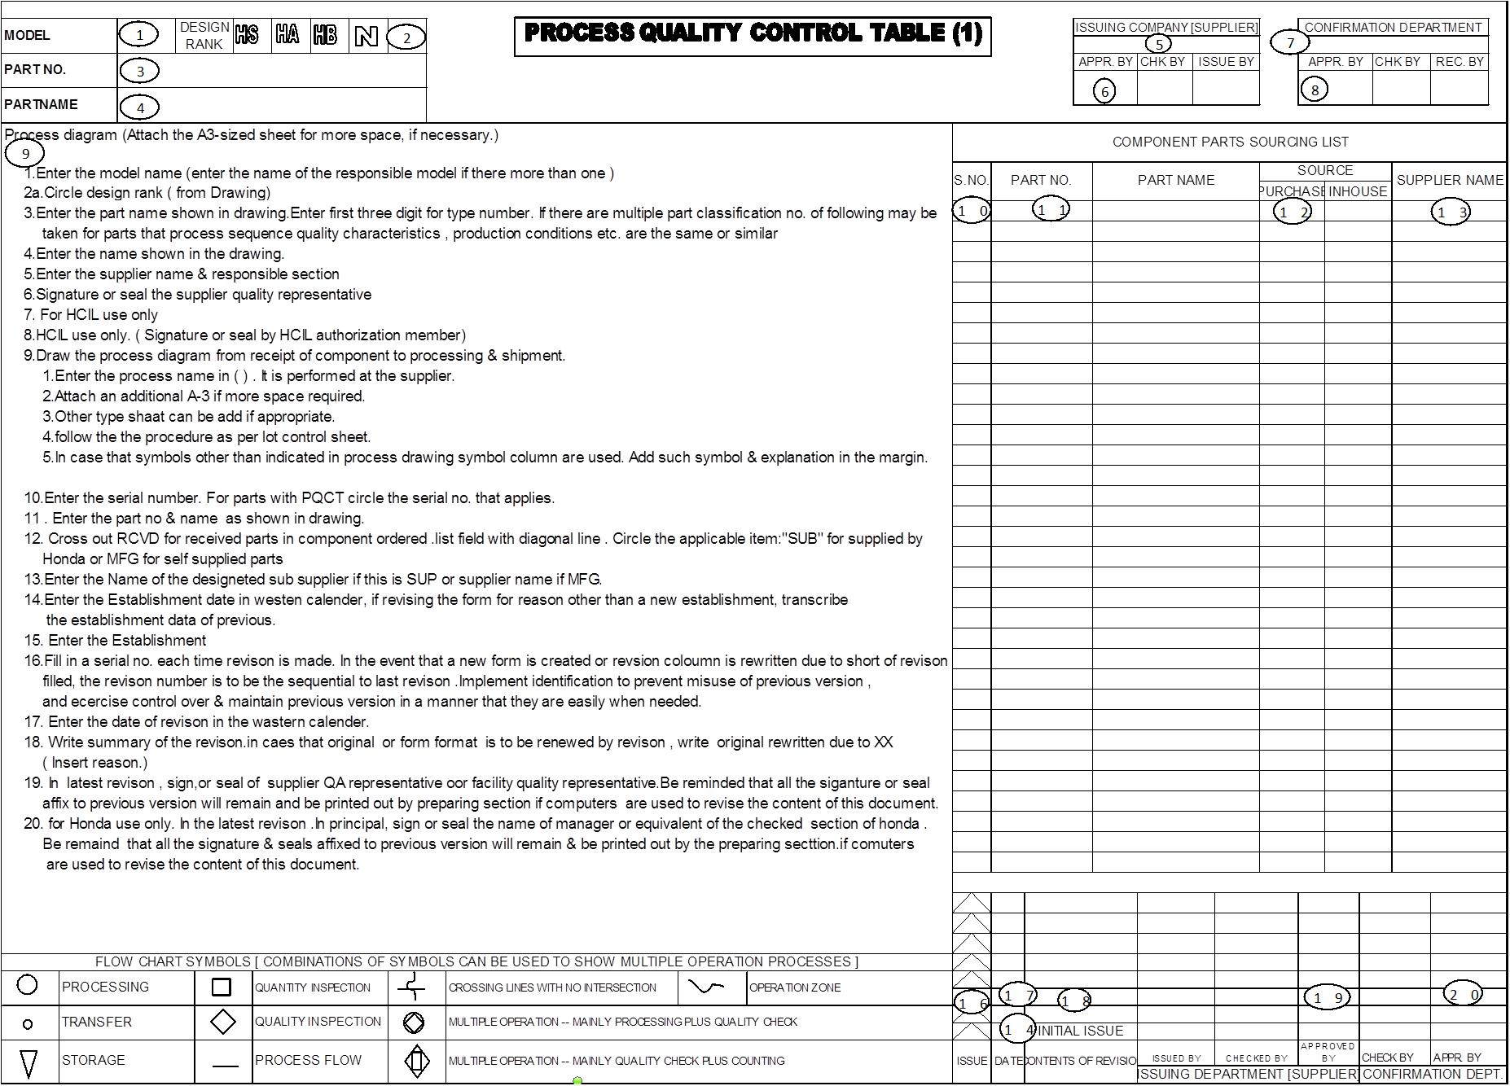
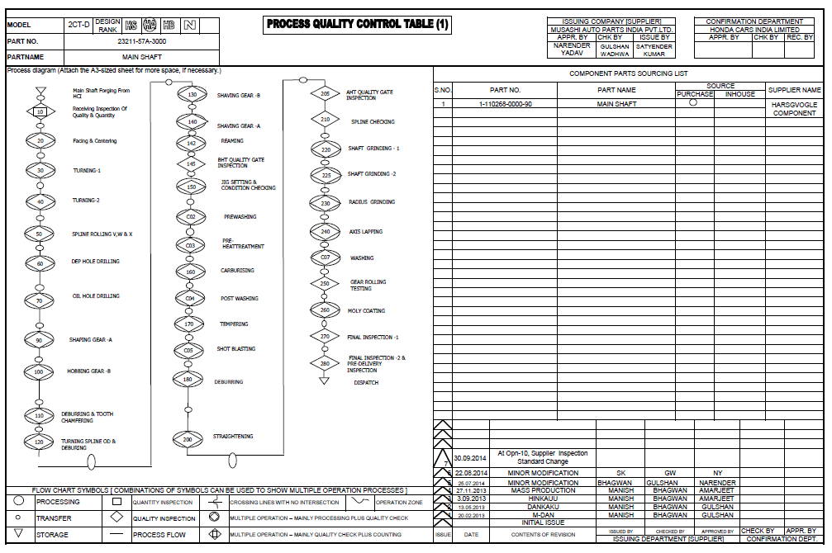
PQCT – 1 format and guidelines to fill:
PQCT – 1 format and guidelines to fill:
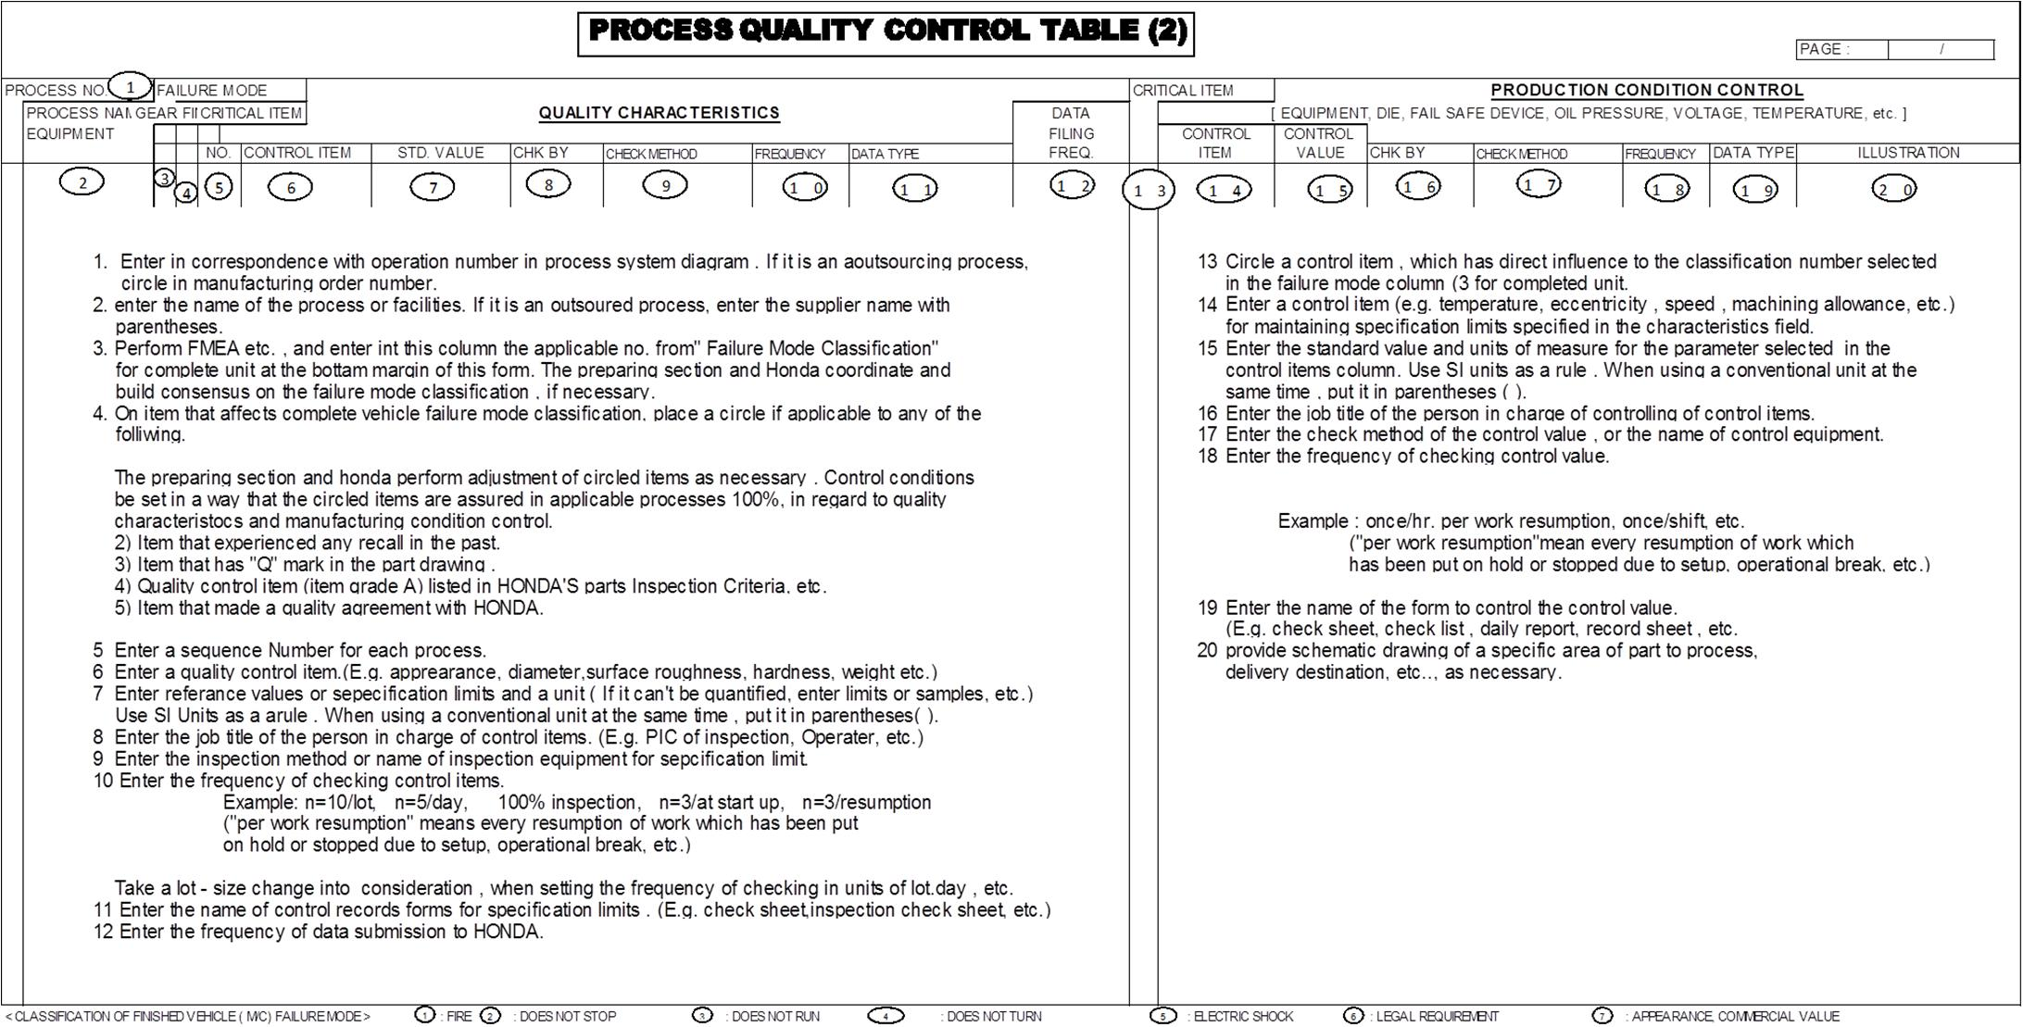
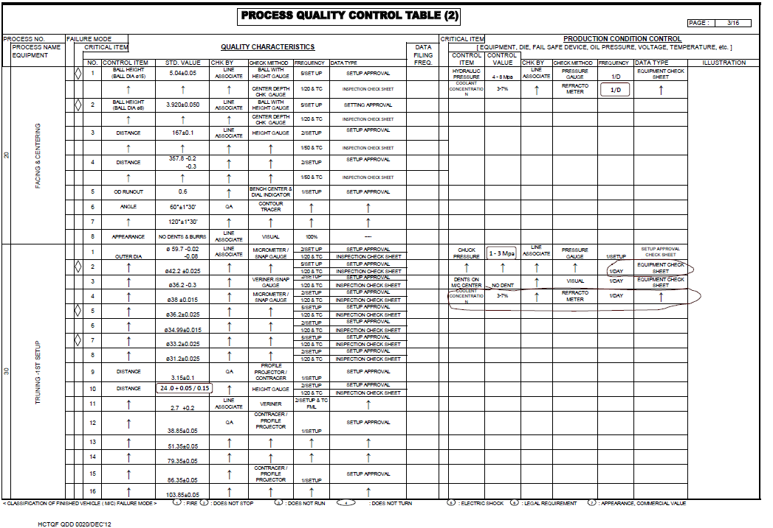
PQCT – 2 format and guidelines to fill:

